

Luong Nguyen Khoi Nguyen

Nguyen Mai Vinh

Thanh Danh Phan

Embedded Programming Project

Ventilation System

Helsinki Metropolia University of Applied Sciences

Bachelor Degree

Date : January ${23}^{rd}$ 2016

|  |  |  |
| --- | --- | --- |
| Author(s)  Title  Number of Pages  Date | Luong Nguyen Khoi Nguyen  Nguyen Mai Vinh  Thanh Danh Phan  Embedded Programming Project  xx pages + x appendices  23rd January 2016 | |
| Degree | Bachelor Degree | |
| Degree Programme | Smart System | |
| Specialisation option | Embedded System | |
| Instructors | Keijo Länsikunnas, Project Manager  Kimmo Sauren, Project Manager | |
|  | | |
| Keywords | |  |

**Contents**

1 Introduction 1

2 General description 1

2.1 Controlling system 1

2.2 Sensor 2

2.2.1 Pressure Sensor 2

2.3 LED Screen and buttons 2

2.4 Implementation 3

3 Principle architecture 5

4 Instruction 5

References 5

Appendices

Appendix 1. Title of the Appendix

Appendix 2. Title of the Appendix

# Introduction

Ventilation system is one of the most important things in big building. Its duty is to maintain the ideal atmosphere by controlling air temperature and humidity as administration settings. As a project of our second year, we have to control a ventilation system located in Metropolia (Espoo Campus) by LPCXpresso 1549 with Modbus.

This project, as schedule, will take approximately 2 months to complete and delivery to the customer.

# General description

## Controlling system

In order to control our ventilation system, we used LPCXpresso 1549 evaluation board, which works with the same IDE name.

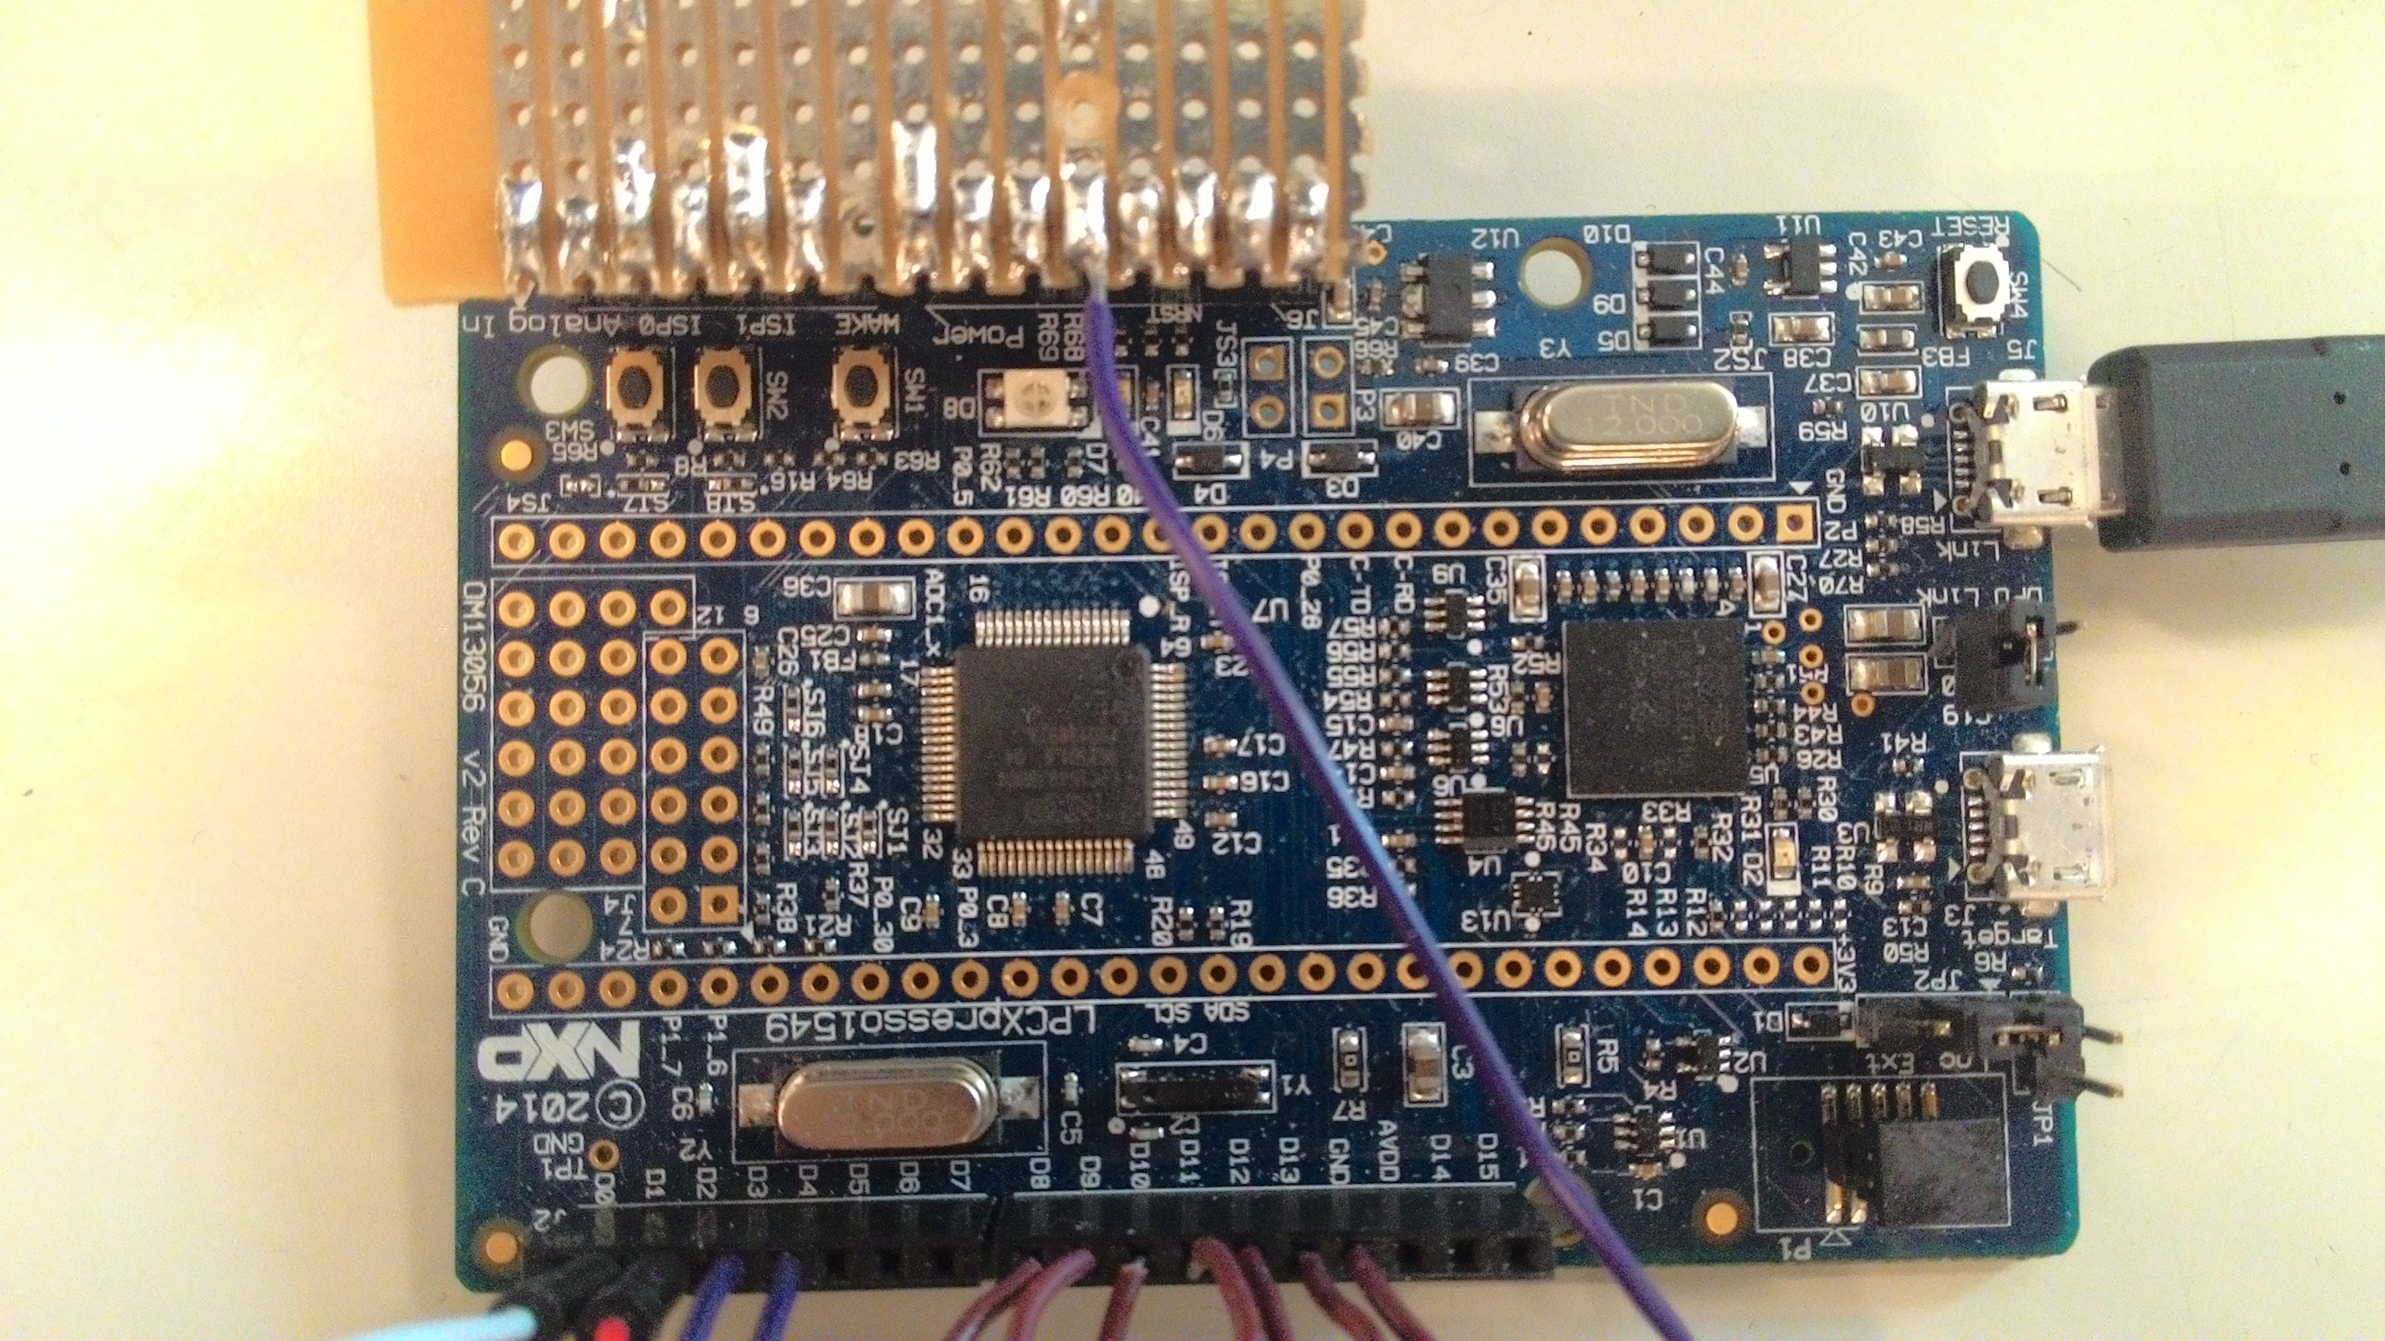

Figure 1. LPCXpresso 1549 evaluation board.

This board uses 32–bit ARM Cortex-M3 microcontroller.

## Sensor

### Pressure Sensor

Add information about pressure sensor

Figure 2. Pressure sensor

Table 1. Pressure Sensor specification

|  |  |
| --- | --- |
| Field of study | Studies completed, ECTS |
| Culture | 131 |
| Technology, Communication and Transport | 552 |
| Health Care and Social Services | 175 |
| Business and Administration | 52 |
| Not bound to a field of study | 18 |
| Metropolia total | 928 |

There must always be text between a figure or table and a new figure or table or a new heading.

## LED Screen and buttons

In order to make the controlling and setting friendly, we ended up with 4 buttons and 1 LCD

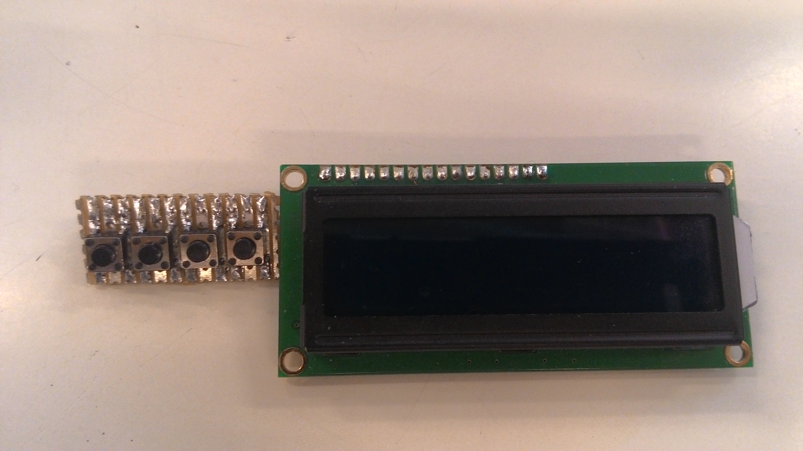

Figure 5. LED Screen and buttons.

This is a 16 characters wide and 2 rows LCD, with white text on blue background. There order of 4 buttons are: up, down, enter and exit (respectively).

## Implementation

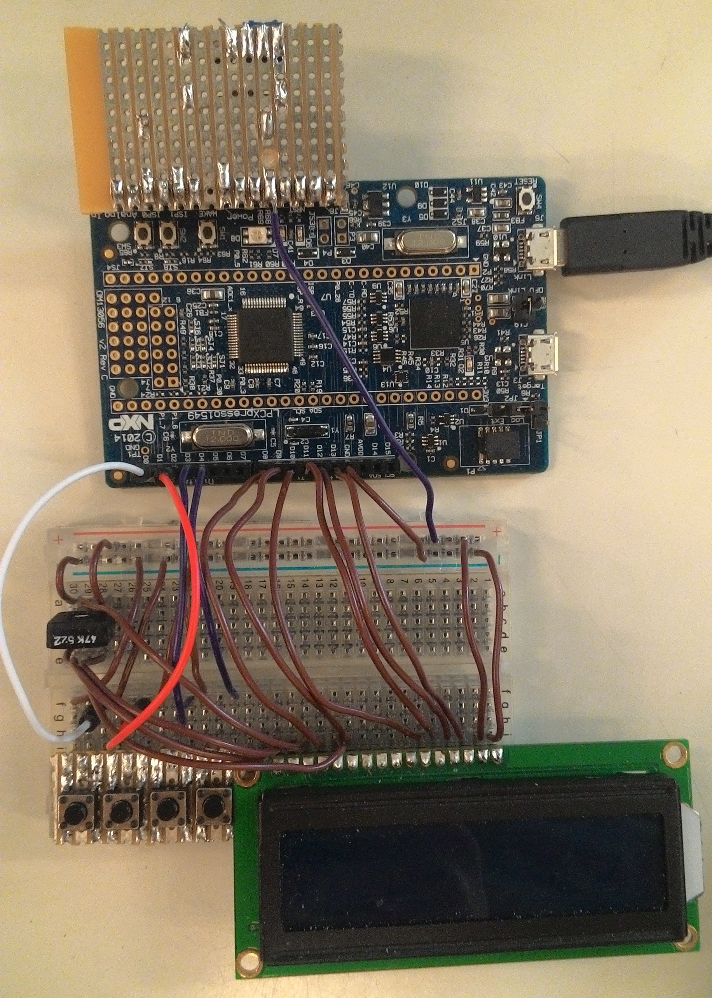

Figure 6. Implementation

As shown in the picture, we also use a trimmer to control the contrast of the LCD.

# Principle architecture

Lorem ipsum dolor sit amet, consectetur adipiscing elit, sed do eiusmod tempor incididunt ut labore et dolore magna aliqua. Ut enim ad minim veniam, quis nostrud exercitation ullamco laboris nisi ut aliquip ex ea commodo consequat. Duis aute irure dolor in reprehenderit in voluptate velit esse cillum dolore eu fugiat nulla pariatur. Excepteur sint occaecat cupidatat non proident, sunt in culpa qui officia deserunt mollit anim id est laborum.

# Instruction

Lorem ipsum dolor sit amet, consectetur adipiscing elit, sed do eiusmod tempor incididunt ut labore et dolore magna aliqua. Ut enim ad minim veniam, quis nostrud exercitation ullamco laboris nisi ut aliquip ex ea commodo consequat. Duis aute irure dolor in reprehenderit in voluptate velit esse cillum dolore eu fugiat nulla pariatur. Excepteur sint occaecat cupidatat non proident, sunt in culpa qui officia deserunt mollit anim id est laborum.

# References

Details of the references are given here. Use the referencing system required in your degree programme or as agreed with your supervisor. Leave one blank line between references.

Layout of this page in the author-date /Harvard) referencing system:

Details of the reference Details of the reference Details of the reference Details of the reference Details of the reference.

Details of the reference Details of the reference Details of the reference Details of the reference Details of the reference.

Layout of this page in the number (Vancouver) referencing system:

1. Details of the reference Details of the reference Details of the reference Details of the reference Details of the reference.
2. Details of the reference Details of the reference Details of the reference Details of the reference Details of the reference.

**Title of the Appendix**

Content of the appendix is placed here.

**Title of the Appendix**

Content of the appendix is placed here.